LAPORAN PENGERJAAN UJI KOMPETENSI KEJURUANSMK MAHARDHIKA BATUJAJAR TAHUN PELAJARAN 2022-2023

KOMPETENSI KEAHLIAN : Rekayasa

Perangkat LunakKELAS : XII RPL 1

NAMA LENGKAP : REVALDI WIDIAN KUSDINAR

NIS 0052135946

PAKET SOAL 3

JENIS APLIKASI : Web

ALOKASI WAKTU : 24 jam

# PENJADWALAN KEGIATAN

*Silahkan buat form penjadwalan dengan excel seperti yang pernah dicontohkan*



# PERSIAPAN PERANGKAT KERAS

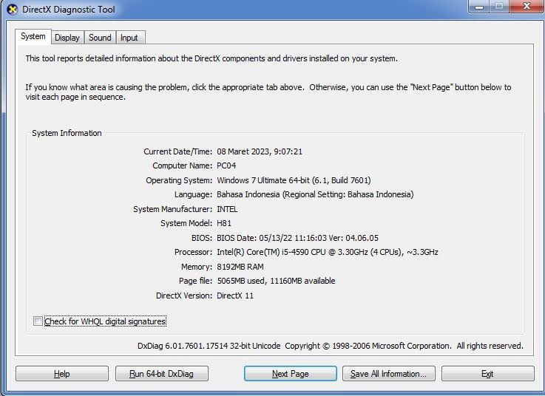*Silahkan isikan deskripsi/spesifikasi dari komputer/laptop yang kamu gunakan*

# PERSIAPAN PERANGKAT LUNAK

*Silahkan isikan perangkat lunak yang terlibat dalam pembuatan project ini*

* 1. Visual Code Studio
  2. Xampp Controller Panel
  3. Astah Profesional
  4. Balsamiq
  5. Google Chrome
  6. Excel
  7. Word

# PERANCANGAN ALGORITMA APLIKASI

*Silahkan gambarkan activity diagram aplikasi yang kamu buat*

* 1. Transaksi

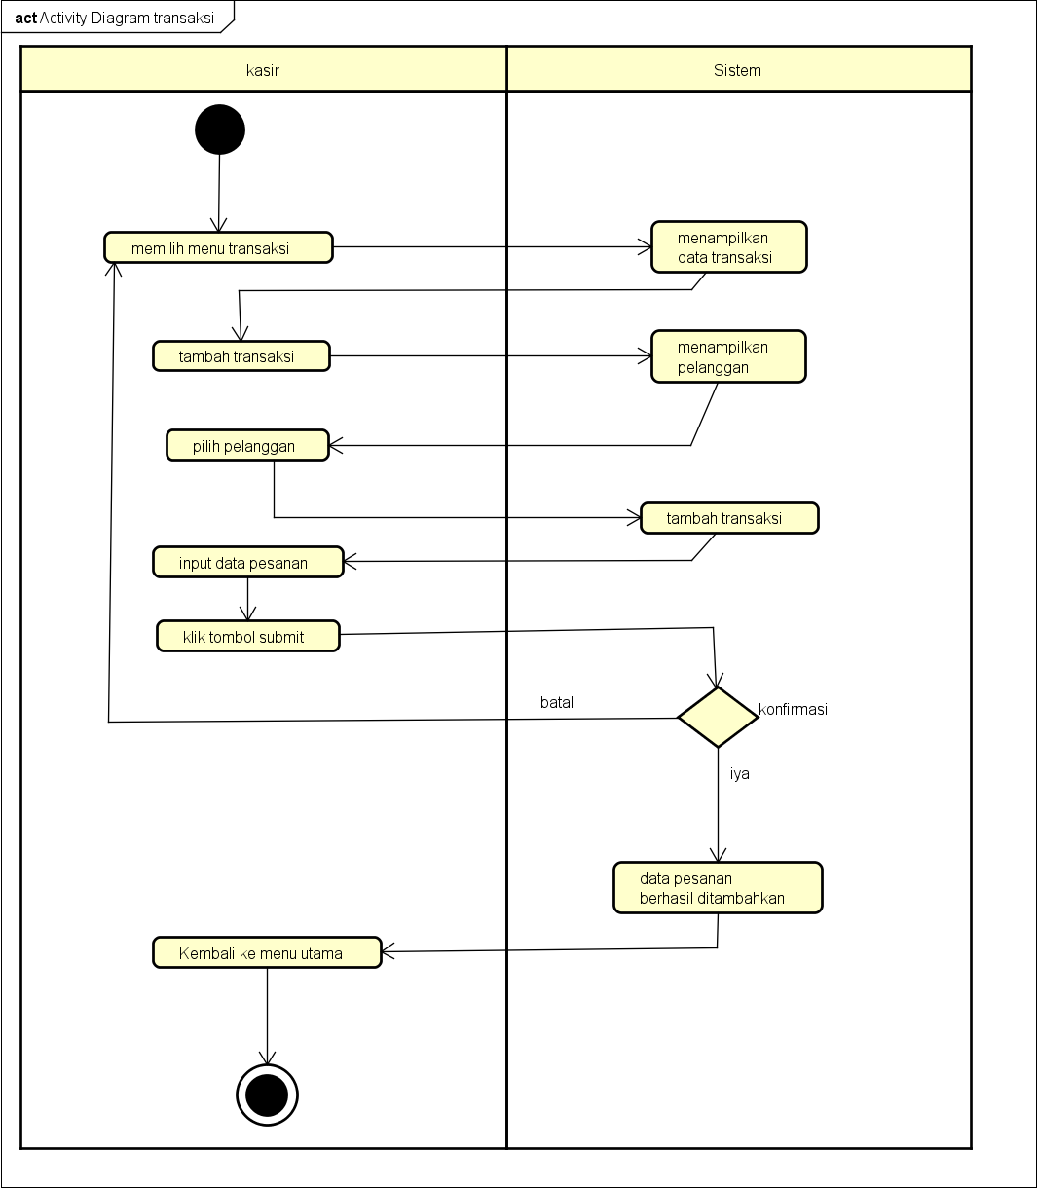

* 1. Tambah Transaksi

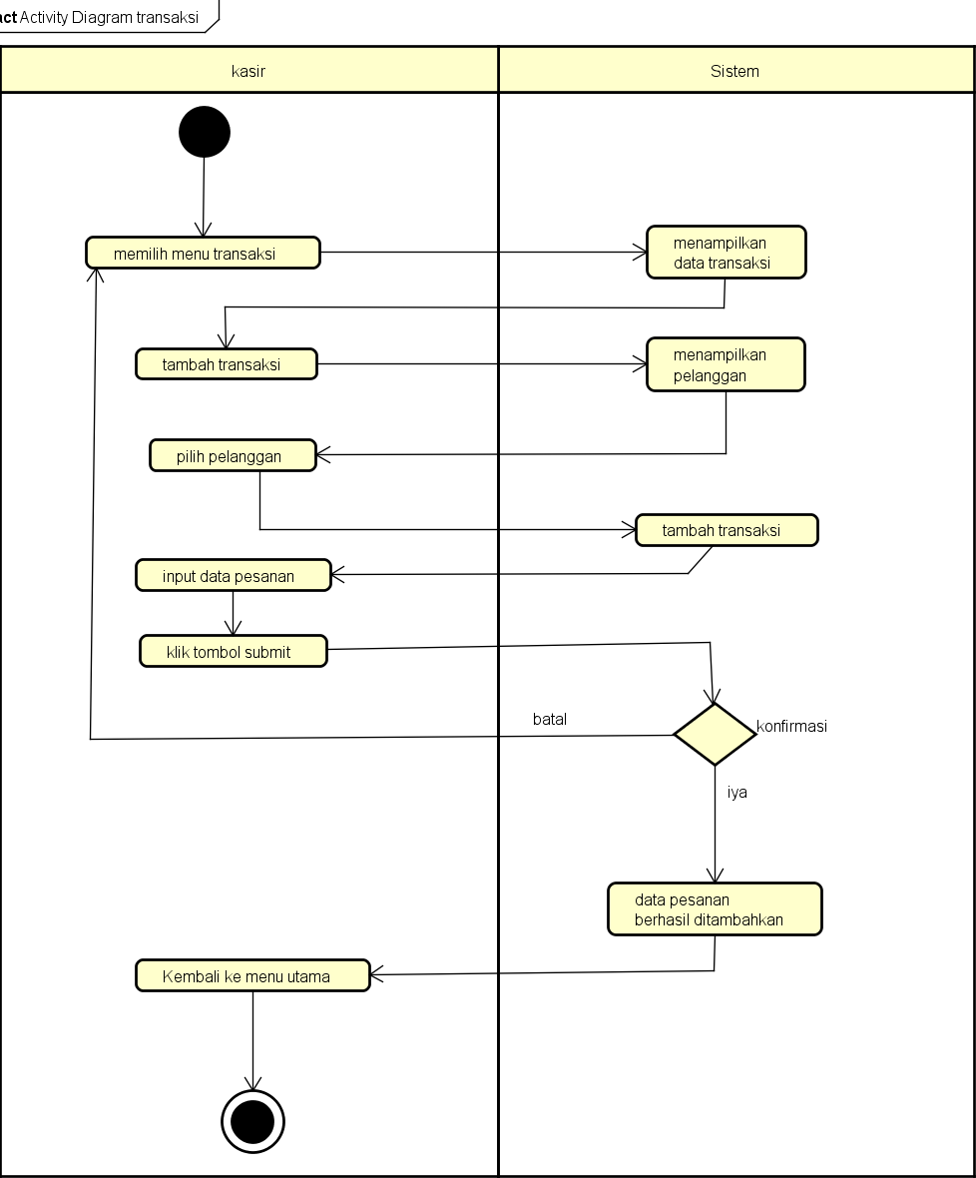

* 1. Tambah Pelanggan

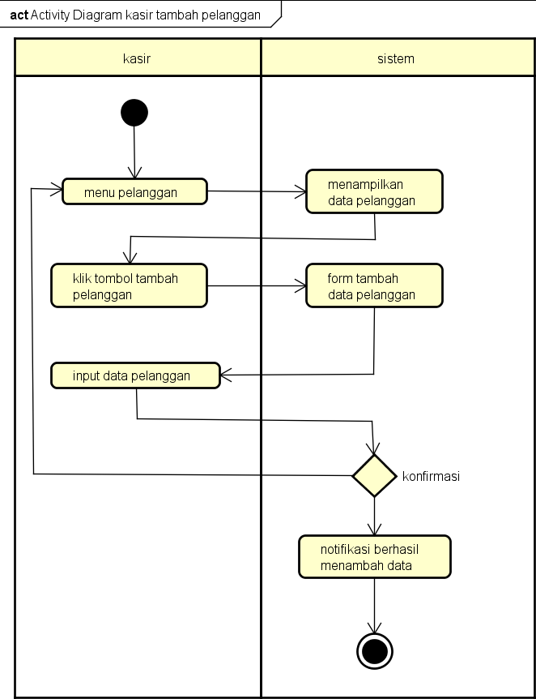

* 1. Konfirmasi Pelanggan

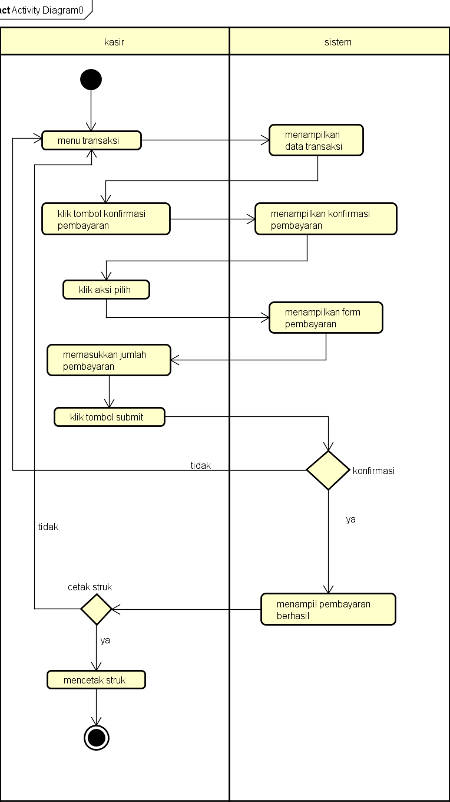

* 1. 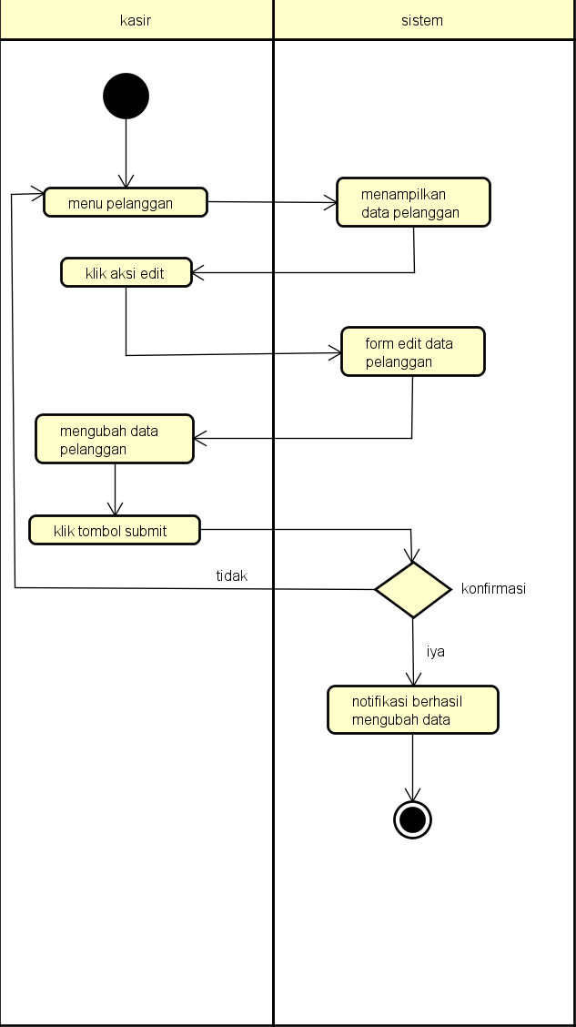Aksi Edit
  2. Aksi Hapus

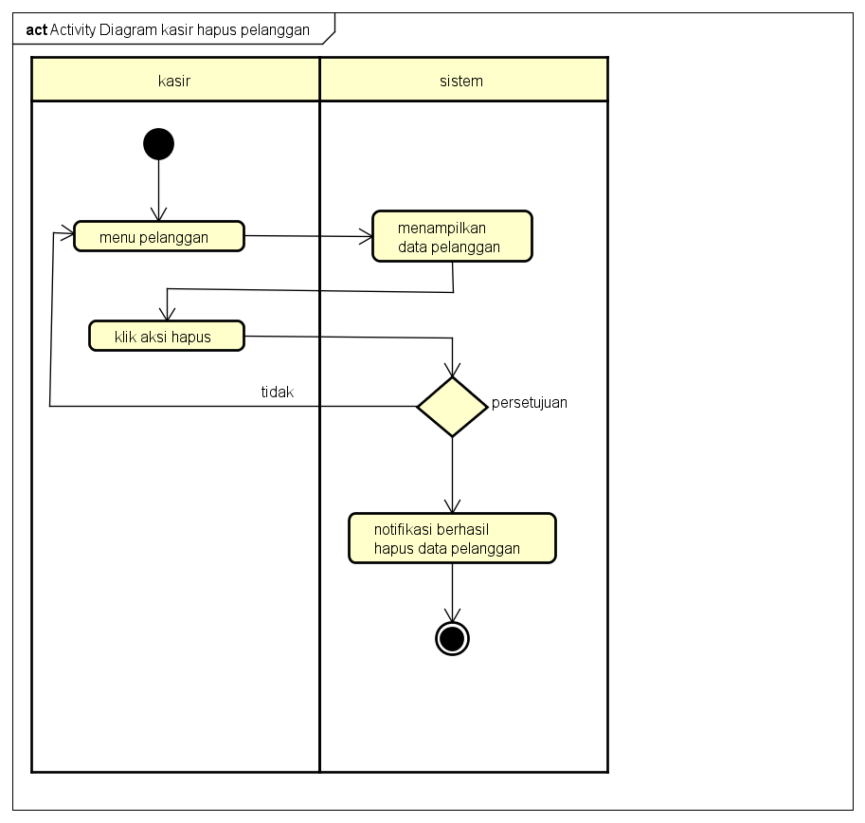

* 1. 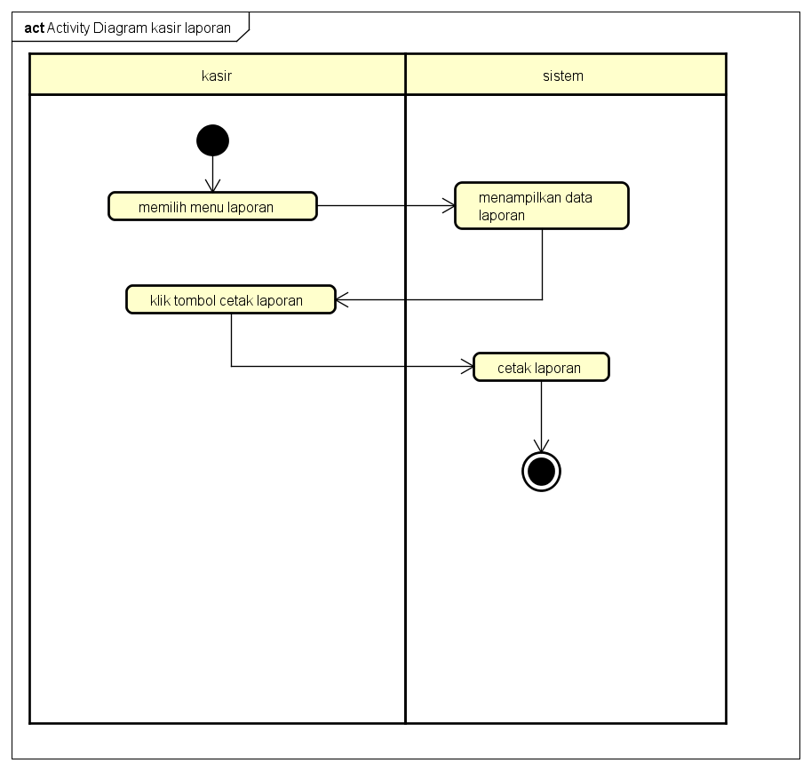Cetak Laporan

# PERANCANGAN DESAIN BASIS DATA

*Silahkan gambarkan ERD/DFD/class diagram atau desain basis data pada phpMyAdmin besertarelasinya*

* DFD

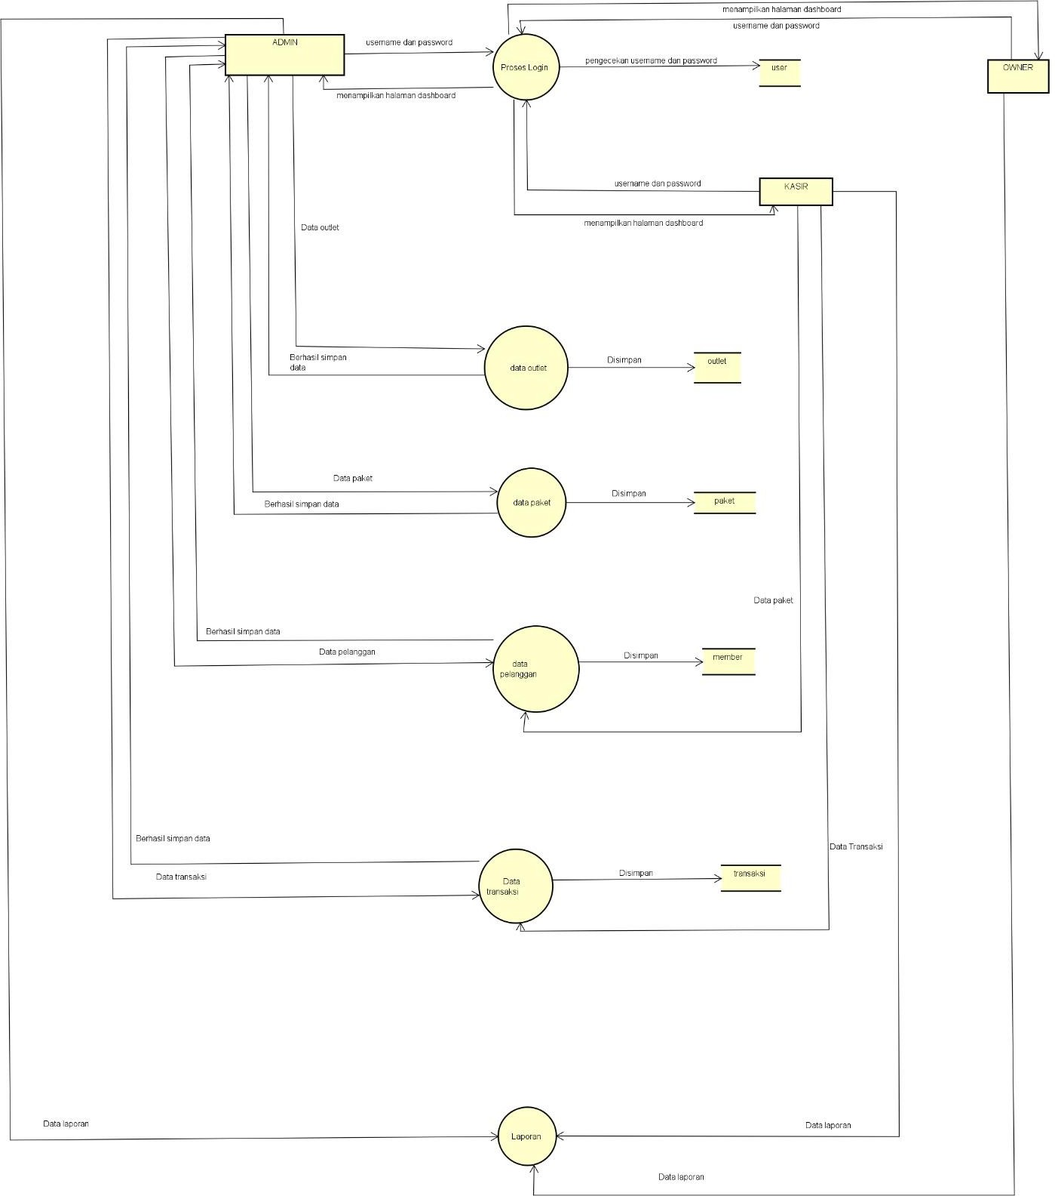

* CLASS DIAGRAM

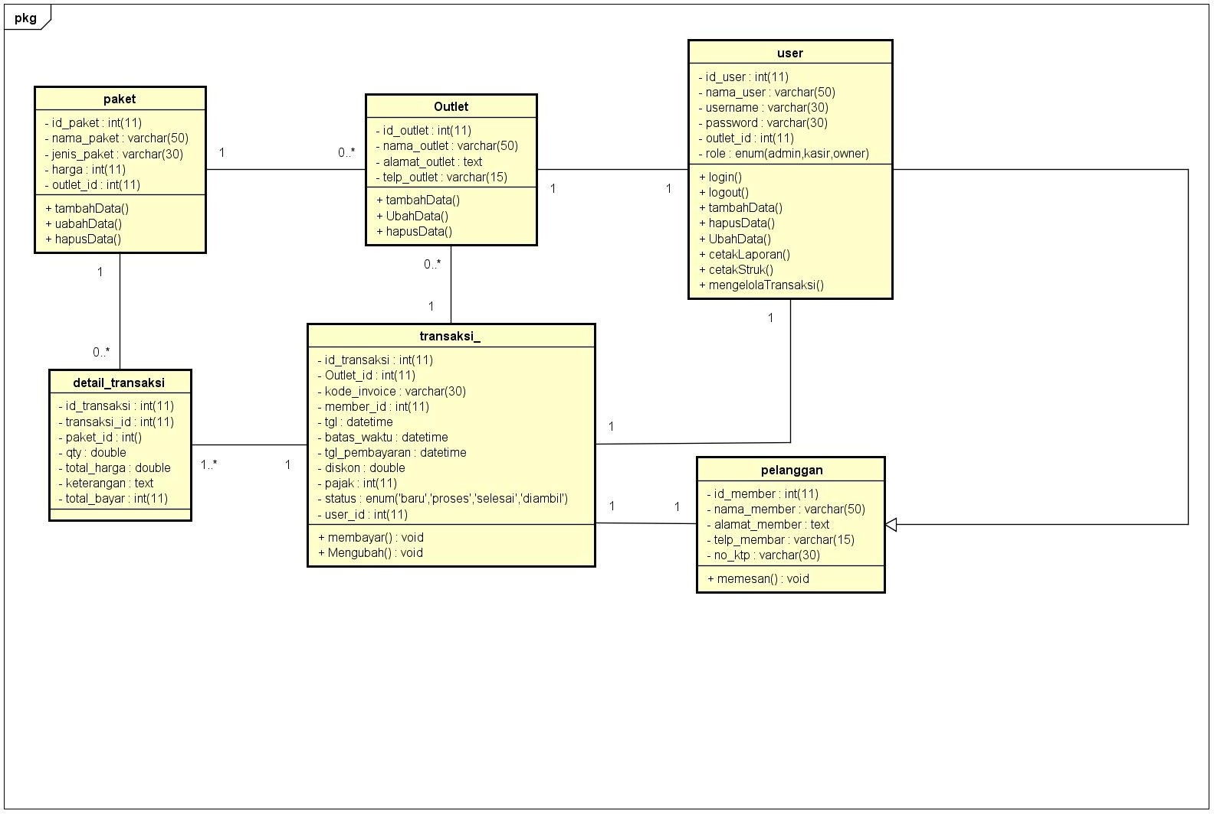

# DUMMY DATA

*Buat data dummy/bohongan yang dipersiapkan untuk nanti dimasukkan*

1. USER

|  |  |  |  |  |  |
| --- | --- | --- | --- | --- | --- |
| *Id_user* | *Nama_user* | *Username* | *Password* | *Outlet_id* | *Role* |
| *98763218421* | *udin* | *udin* | *Udin123* | *1* | *admin* |
| *12324176472* | *Saep* | *Saepul* | *12345678* | *2* | *Owner* |
| *76262621246* | *Surip* | *Suripan* | *12146778* | *3* | *owner* |
| *82716642514* | *Kartika* | *Kartikaa1* | *Kartika113* | *4* | *kasir* |
| *88829166521* | *Usep* | *usepulloh* | *Sepulloh1* | *5* | *kasir* |

1. PELANGGAN

|  |  |  |  |  |  |
| --- | --- | --- | --- | --- | --- |
| Id_pelanggan | Nama_pelangg an | Alamat_pelanggan | Jenis_kel amin | Telp_pelanggan | No_ktp |
| 27 | Dita | Cibeber cimahi selatan | p | 08773792177 | 32779147612647214 |
| 12 | Saep | Cibeber cimahi selatan | L | 98417762412 | 32777421641246127 |
| 10 | Surip | Cibeber cimahi selatan | L | 09827174721 | 32777241617221441 |
| 4 | Kartika | Cibeber cimahi selatan | P | 08774261655 | 32778912741612211 |
| 1 | Usep | Cibeber cimahi selatan | L | 08721641551 | 32984126146216422 |

1. OUTLET

|  |  |  |  |
| --- | --- | --- | --- |
| *Id_outlet* | *Nama_outlet* | *Alamat_outlet* | *Telp_outlet* |
| *9* | *Outlet merah* | *yogyakarta* | *0214546794512364* |
| *10* | *Outlet putih* | *bantul* | *0214127414512261* |
| *12* | *Outlet biru* | *klaten* | *1827481924761228* |
| *15* | *Outlet abuabu* | *ciranjang* | *0987276165215155* |
| *14* | *Outlet hijau* | *cikudapateuh* | *0891726152155261* |

1. PAKET

|  |  |  |  |  |
| --- | --- | --- | --- | --- |
| *Id_paket* | *Jenis_paket* | *Nama_paket* | *harga* | *Outlet_id* |
| *20* | *Kiloan* | *Paket wangi tahan lama* | *20.000* | *11* |
| *21* | *Kaos* | *Paket cepat kering* | *15.000* | *1* |
| *22* | *Selimut* | *Paket harum* | *15.000* | *10* |
| *23* | *Bedcover* | *Paket wangi* | *25.000* | *14* |
| *24* | *lain* | *Cool* | *15.000* | *13* |

# PEMBUATAN BASIS DATA (MySQL Code)

*Silahkan buat basis data di PHPMyAdmin, jika sudah selesai bisa di copykan filenya di sini sebagailampiran (*screenshot struktur tabel pada basis data yg dibuat)*

* 1. Tabel user

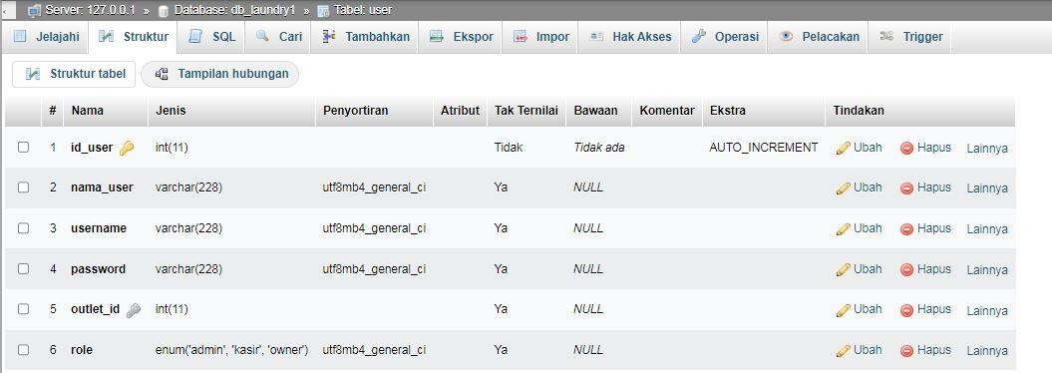

* 1. 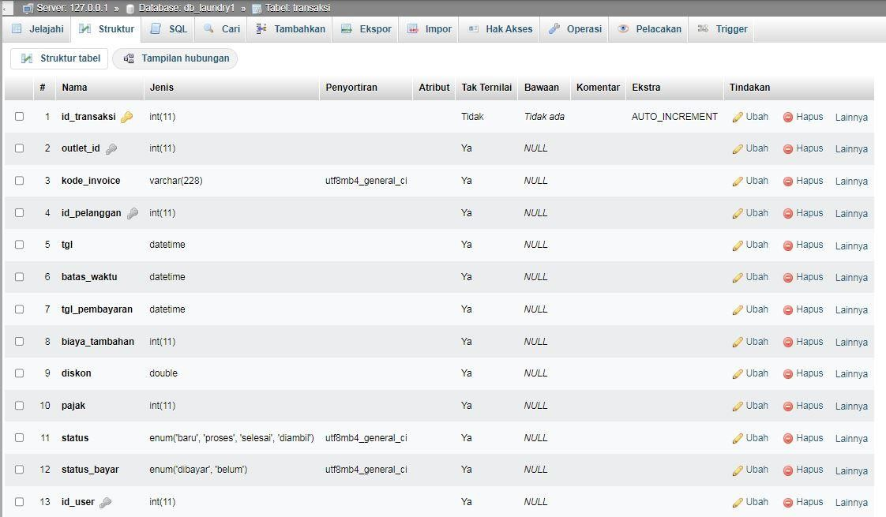Tabel Transaksi
  2. Tabel Pelanggan

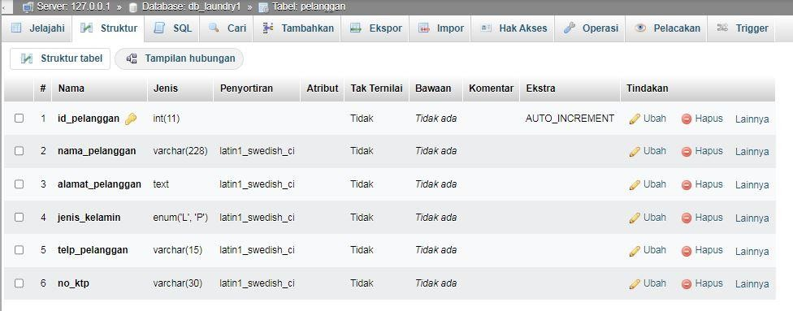

* 1. *Tabel paket cuci*

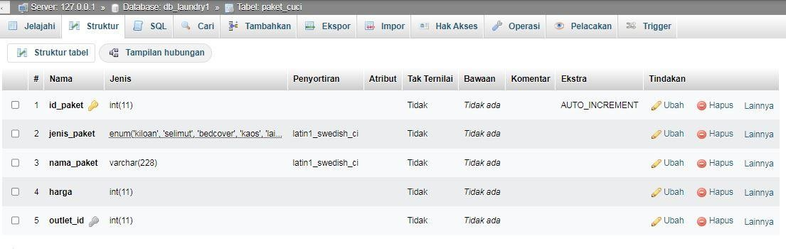

* 1. 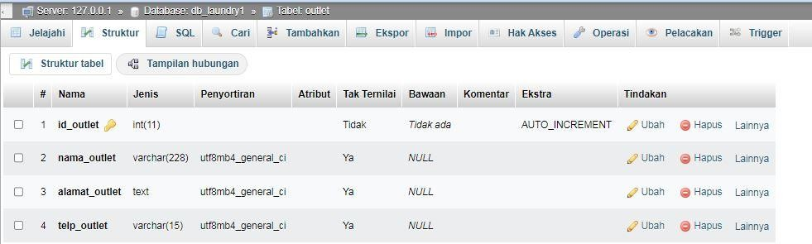*Tabel paket outlet*
  2. *Tabel Detail transaksi*

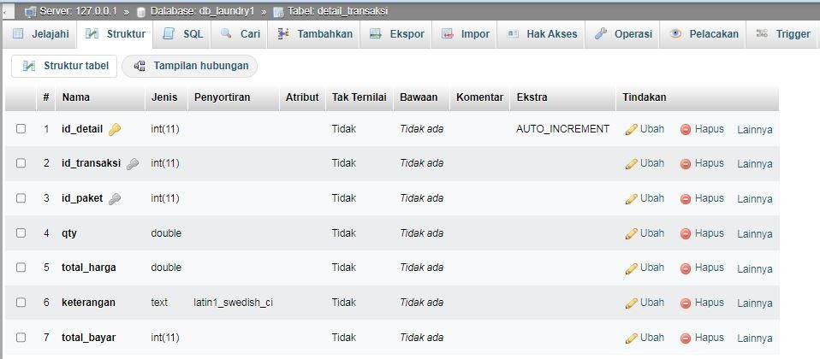

# PERANCANGAN TAMPILAN ANTARMUKA (UI) WEB

* **Aplikasi pengelolaan laundry**
  1. 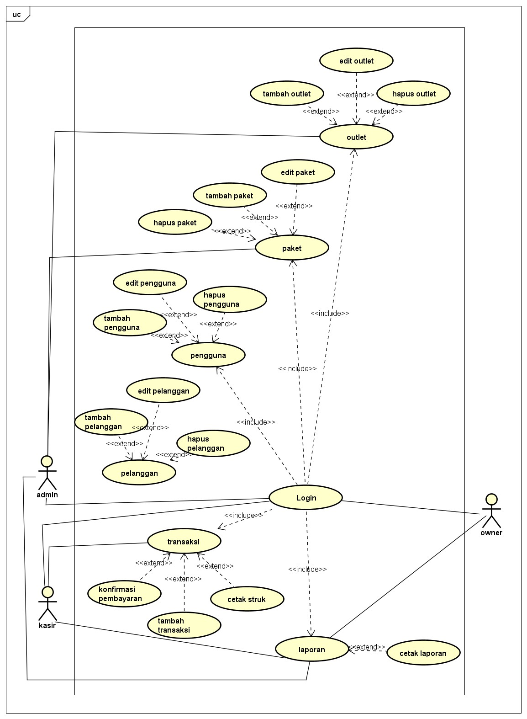*Silahkan gambarkan use case diagram aplikasi yang kamu buat*

*-=*

* 1. Admin dashboard

Tampilan untuk full manage semua data, buatkan sketsa/mockup-nya

* + 1. Tampilan login

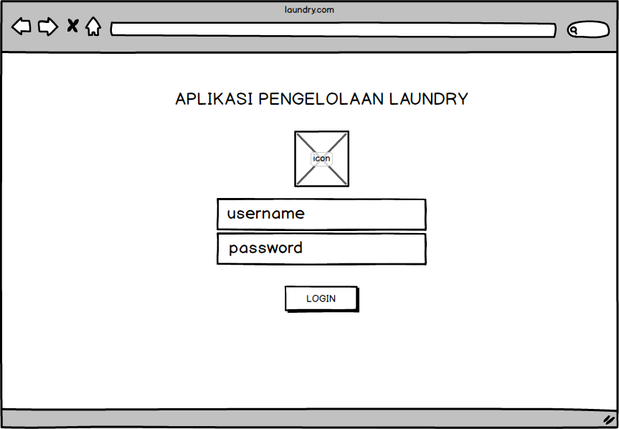

* + 1. Tampilan dashboard admin

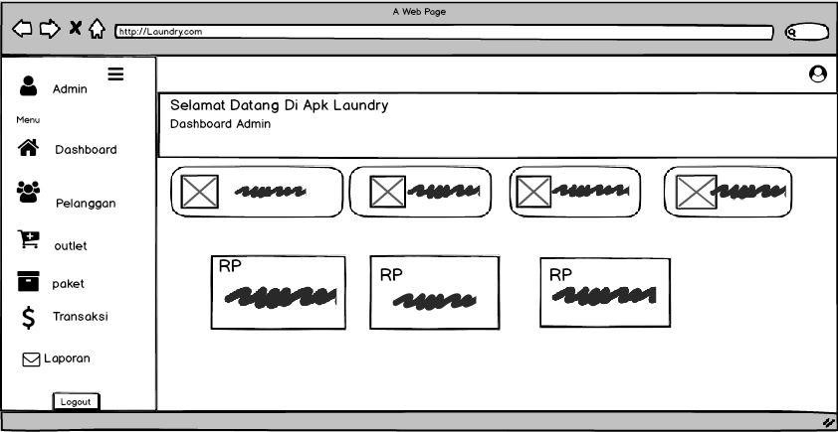

* + 1. Tampilan tambah pelanggan

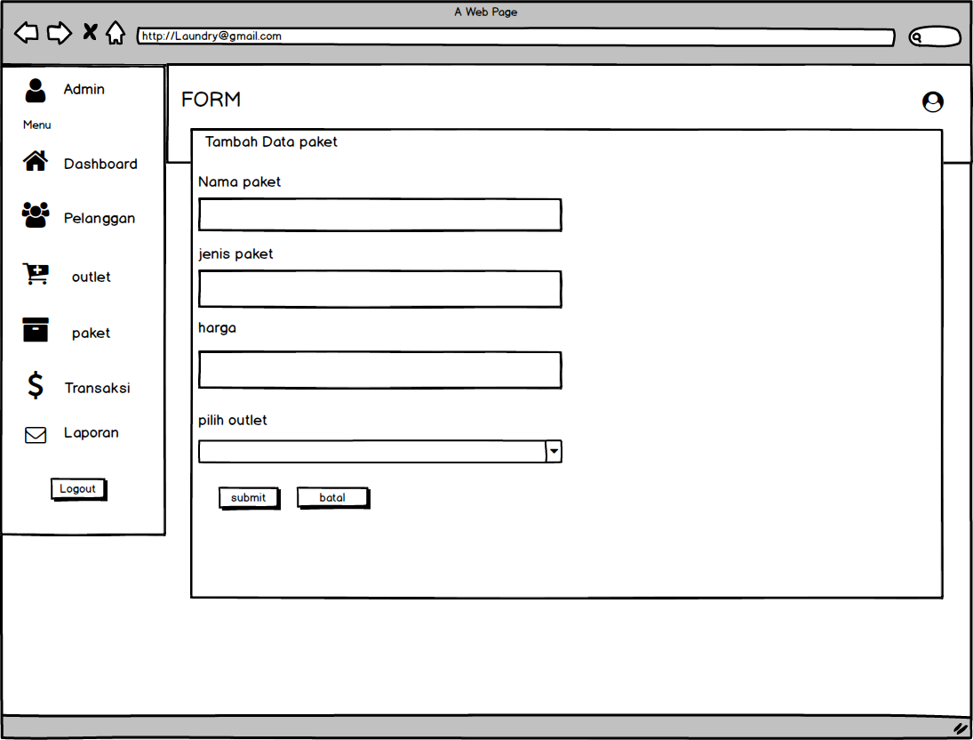

* + 1. Tampilan edit pelanggan

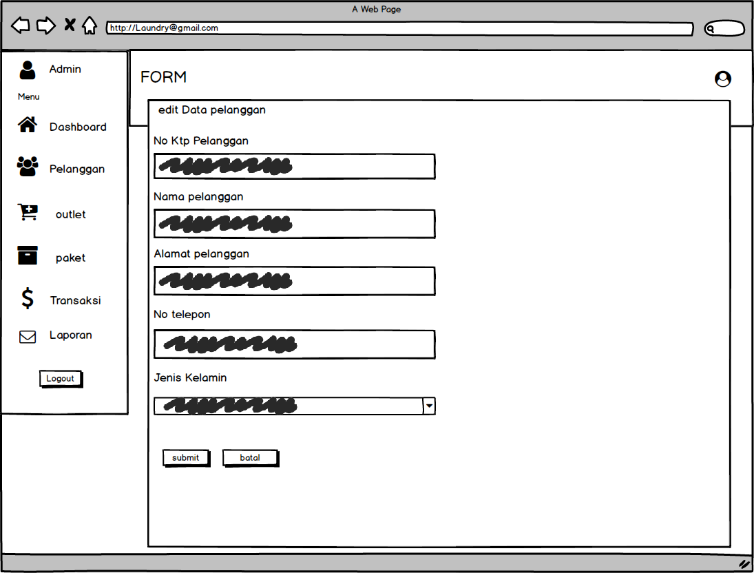

* 1. Tampilan Kasir

Setiap menu buatkan sketsa/mockup-nya

* + 1. 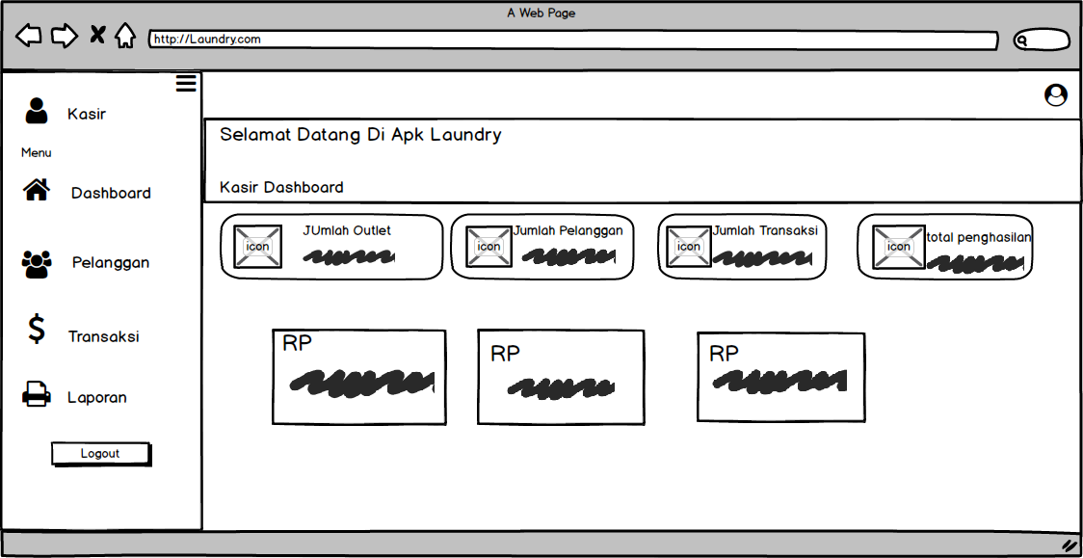Dashboard Kasir
    2. Tampil Tambah Pelanggan

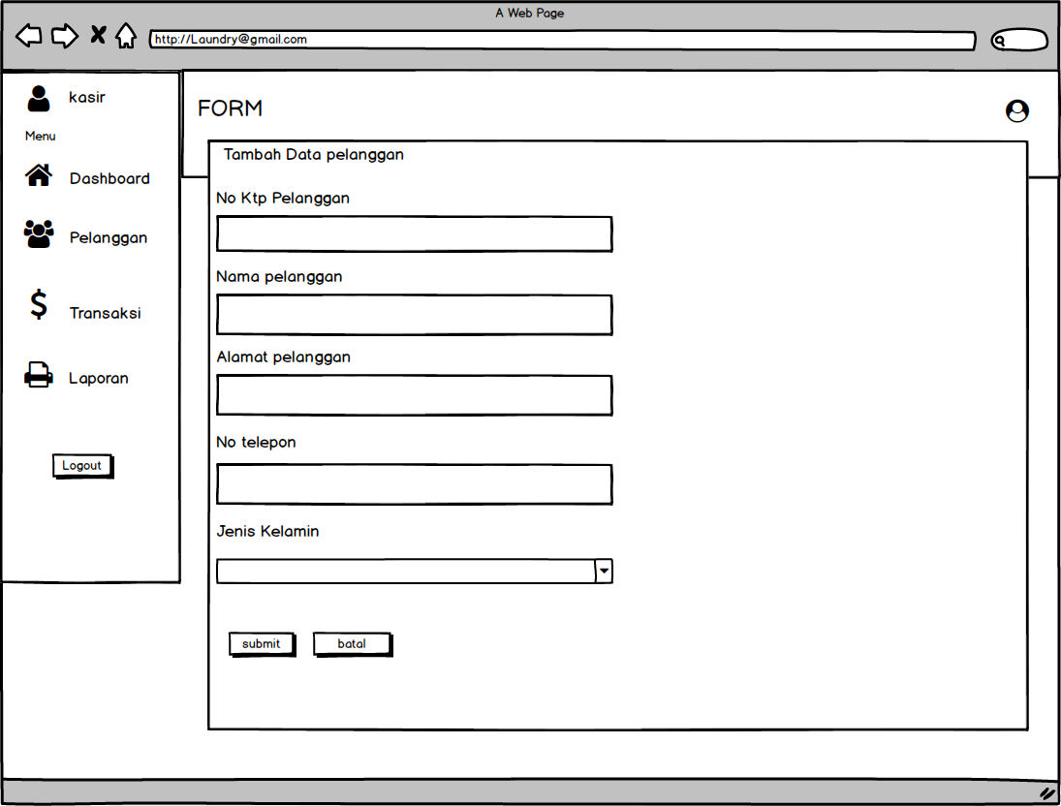

* + 1. Tampil edit Pelanggan

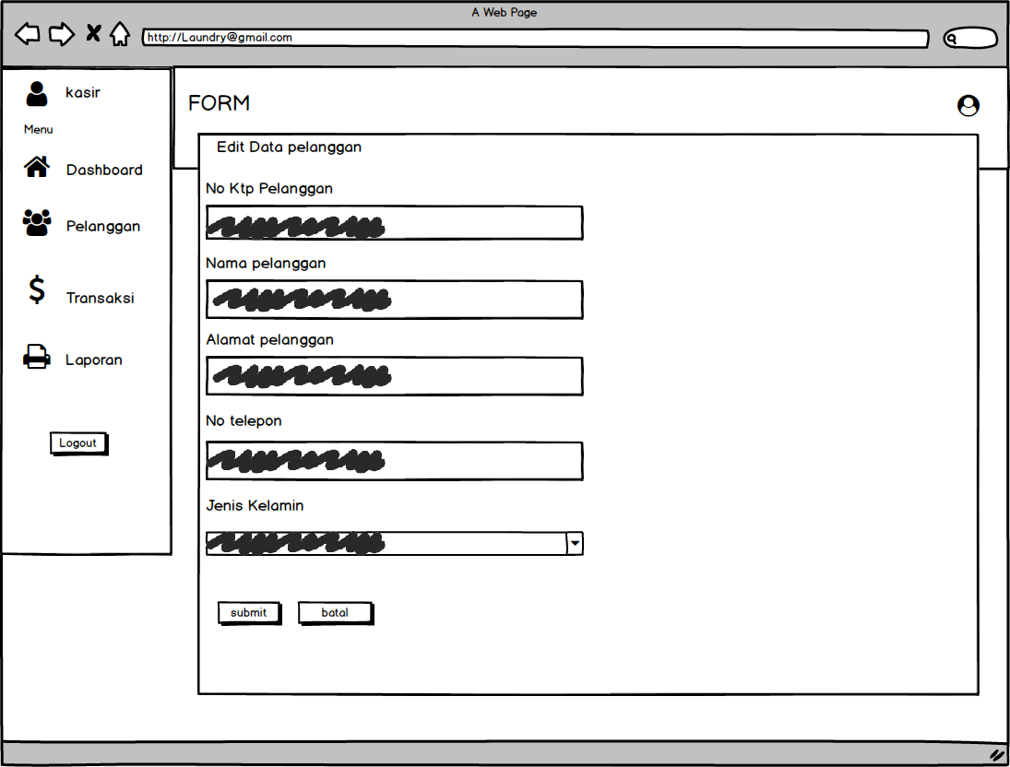

* 1. Tampilan owner

Setiap menu buatkan sketsa/mockup-nya

* + 1. Dashboard Owner

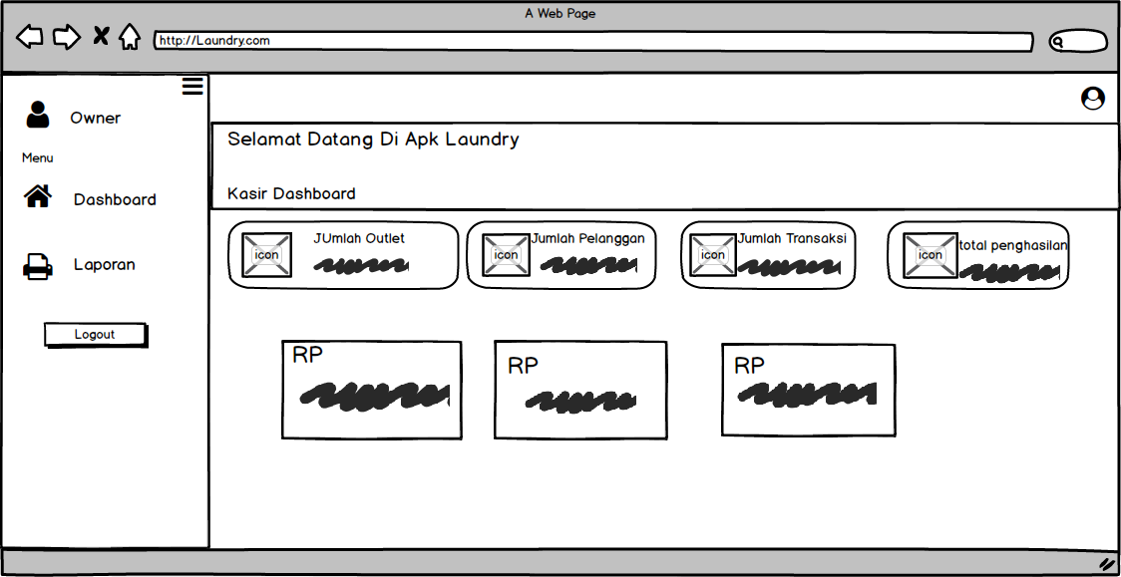

# PERANCANGAN TAMPILAN ANTARMUKA (UI) WEB File style.css

html, body {

height: 100%;

}

body {

display: -ms-flexbox; display: flex;

-ms-flex-align: center; align-items: center; padding-top: 40px; padding-bottom: 40px; background-color: #f5f5f5;

}

.form-signin { width: 100%;

max-width: 330px; padding: 15px; margin: auto;

}

.form-signin .checkbox { font-weight: 400;

}

.form-signin .form-control { position: relative;

box-sizing: border-box; height: auto;

padding: 10px; font-size: 16px;

}

.form-signin .form-control:focus { z-index: 2;

}

.form-signin input[type="email"] { margin-bottom: -1px;

border-bottom-right-radius: 0;

border-bottom-left-radius: 0;

}

.form-signin input[type="password"] { margin-bottom: 10px;

border-top-left-radius: 0;

border-top-right-radius: 0;

1. **PERANCANGAN TAMPILAN ANTARMUKA (UI) WEB**
2. Login.php

<!doctype html>

<html lang="en">

<head>

<meta charset="utf-8">

<meta name="viewport" content="width=device-width, initial-scale=1, shrink-to-fit=no">

<meta name="description" content="">

<meta name="author" content="Mark Otto, Jacob Thornton, and Bootstrap contributors">

<meta name="generator" content="Hugo 0.101.0">

<title>Login</title>

<link rel="canonical" href="https://getbootstrap.com/docs/4.6/examples/sign-in/">

<!-- Bootstrap core CSS -->

<link href="assets/css/bootstrap.min.css" rel="stylesheet">

<style>

.bd-placeholder-img { font-size: 1.125rem; text-anchor: middle;

-webkit-user-select: none;

-moz-user-select: none;

-ms-user-select: none; user-select: none;

}

@media (min-width: 768px) {

.bd-placeholder-img-lg { font-size: 3.5rem;

}

}

</style>

<!-- Custom styles for this template -->

<link href="assets/css/signin.css" rel="stylesheet">

</head>

<body class="text-center">

<form class="form-signin" action="cek_login.php" method="post">

<h2 class="h3-mb-3 font-weight-normal">Aplikasi Pengelolaan Laundry</h2>

<img class="mb-4" src="bg.jpg" alt="" width="200" height="125">

<label for="inputusernaname" class="sr-only">Username</label>

<input name="username" type="username" id="username" class="form- control" placeholder="username" required autofocus>

<label for="inputpassword" class="sr-only">password</label>

<input name="password" type="password" id="password" class="form- control" placeholder="password" required>

</div>

<button class="btn btn-lg btn-primary btn-block" type="submit">Login</button>

<p> Terjamin Wangi Saumur Hidup</p>

</form>

</body>

**</html>**

1. Index.php

<?php

$title = 'Selamat Datang di Aplikasi Pengelolaan Laundry Revaldii'; require 'koneksi.php';

require 'header.php';

setlocale(LC_ALL, 'id_id'); setlocale(LC_TIME, 'id_ID.utf8');

$query = mysqli_query($conn, "SELECT COUNT(id_transaksi) as jumlah_transaksi FROM transaksi");

$jumlah_transaksi = mysqli_fetch_assoc($query);

$query2 = mysqli_query($conn, "SELECT COUNT(id_pelanggan) as jumlah_pelanggan FROM pelanggan");

$jumlah_pelanggan = mysqli_fetch_assoc($query2);

$query3 = mysqli_query($conn, "SELECT COUNT(id_outlet) as jumlah_outlet FROM

outlet");

$jumlah_outlet = mysqli_fetch_assoc($query3);

$query4 = mysqli_query($conn, "SELECT SUM(total_harga) as total_penghasilan FROM detail_transaksi INNER JOIN transaksi ON transaksi.id_transaksi = detail_transaksi.id_transaksi WHERE status_bayar = 'dibayar'");

$total_penghasilan = mysqli_fetch_assoc($query4);

$query5 = mysqli_query($conn, "SELECT SUM(total_harga) as penghasilan_tahun FROM detail_transaksi INNER JOIN transaksi ON transaksi.id_transaksi = detail_transaksi.id_transaksi WHERE status_bayar = 'dibayar' AND YEAR(tgl_pembayaran) = YEAR(NOW())");

$penghasilan_tahun = mysqli_fetch_assoc($query5);

$query6 = mysqli_query($conn, "SELECT SUM(total_harga) as penghasilan_bulan FROM detail_transaksi INNER JOIN transaksi ON transaksi.id_transaksi = detail_transaksi.id_transaksi WHERE status_bayar = 'dibayar' AND MONTH(tgl_pembayaran) = MONTH(NOW())");

$penghasilan_bulan = mysqli_fetch_assoc($query6);

$query7 = mysqli_query($conn, "SELECT SUM(total_harga) as penghasilan_minggu FROM detail_transaksi INNER JOIN transaksi ON transaksi.id_transaksi = detail_transaksi.id_transaksi WHERE status_bayar = 'dibayar' AND WEEK(tgl_pembayaran) = WEEK(NOW())");

$penghasilan_minggu = mysqli_fetch_assoc($query7);

?>

<div class="panel-header bg-secondary-gradient">

<div class="page-inner py-5">

<div class="d-flex align-items-left align-items-md-center flex-column flex-md- row">

<div>

<h1 class="text-white pb-2 fw-bold"><?= $title; ?></h1>

<h2 class="text-white op-7 mb-2">Dashboard Admin</h2>

</div>

</div>

</div>

</div>

<div class="page-inner mt--5">2

<div class="row">

<div class="col-sm-6 col-md-3">

<div class="card card-stats card-round">

<div class="card-body ">

<div class="row align-items-center">

<div class="col-icon">

<div class="icon-big text-center icon-primary bubble-shadow-

small">

<i class="fas fa-shopping-basket"></i>

</div>

</div>

<div class="col col-stats ml-3 ml-sm-0">

<div class="numbers">

<p class="card-category">Jumlah Outlet</p>

<h4 class="card-title"><?= $jumlah_outlet['jumlah_outlet'];

?></h4>

</div>

</div>

</div>

</div>

</div>

</div>

<div class="col-sm-6 col-md-3">

<div class="card card-stats card-round">

<div class="card-body">

<div class="row align-items-center">

<div class="col-icon">

<div class="icon-big text-center icon-info bubble-shadow-small">

<i class="fas fa-users"></i>

</div>

</div>

<div class="col col-stats ml-3 ml-sm-0">

<div class="numbers">

<p class="card-category">Jumlah Pelanggan</p>

<h4 class="card-title"><?=

$jumlah_pelanggan['jumlah_pelanggan']; ?></h4>

</div>

</div>

</div>

</div>

</div>

</div>

<div class="col-sm-6 col-md-3">

<div class="card card-stats card-round">

<div class="card-body">

<div class="row align-items-center">

<div class="col-icon">

<div class="icon-big text-center icon-secondary bubble-shadow-

small">

<i class="flaticon-success"></i>

</div>

</div>

<div class="col col-stats ml-3 ml-sm-0">

<div class="numbers">

<p class="card-category">Jumlah Transaksi</p>

<h4 class="card-title"><?= $jumlah_transaksi['jumlah_transaksi'];

?></h4>

</div>

</div>

</div>

</div>

</div>

</div>

<div class="col-sm-6 col-md-3">

<div class="card card-stats card-round">

<div class="card-body">

<div class="row align-items-center">

<div class="col-icon">

<div class="icon-big text-center icon-success bubble-shadow-

small">

<i class="flaticon-graph"></i>

</div>

</div>

<div class="col col-stats ml-3 ml-sm-0">

<div class="numbers">

<p class="card-category">Total Penghasilan</p>

<h4 class="card-title"><?= 'Rp ' . number_format($total_penghasilan['total_penghasilan']); ?></h4>

</div>

</div>

</div>

</div>

</div>

</div>

</div>

<div class="row">

<div class="col-lg-4 col-sm-6 col-xs-12">

<div class="card card-secondary">

<div class="card-body skew-shadow">

<h1><?= 'Rp ' .

number_format($penghasilan_tahun['penghasilan_tahun']); ?></h1>

<h5 class="op-8">Penghasilan Tahun <?= date('Y'); ?></h5>

<div class="pull-right">

<h3 class="fw-bold op-8">

<hr>

</h3>

</div>

</div>

</div>

</div>

<div class="col-md-4">

<div class="card card-dark bg-secondary-gradient">

<div class="card-body bubble-shadow">

<h1><?= 'Rp ' .

number_format($penghasilan_bulan['penghasilan_bulan']); ?></h1>

<h5 class="op-8">Penghasilan Bulan <?= strftime('%B'); ?></h5>

<div class="pull-right">

<h3 class="fw-bold op-8">

<hr>

</h3>

</div>

</div>

</div>

</div>

<div class="col-md-4">

<div class="card card-dark bg-secondary2">

<div class="card-body curves-shadow">

<h1><?= 'Rp ' .

number_format($penghasilan_minggu['penghasilan_minggu']); ?></h1>

<h5 class="op-8">Penghasilan Minggu Ini</h5>

<div class="pull-right">

<h3 class="fw-bold op-8">

<hr>

</h3>

</div>

</div>

</div>

</div>

</div>

</div>

</div>

</div>

<?php

require 'footer.php';

?>

c) Koneksi.php

<?php session_start(); if ($_SESSION) {

if ($_SESSION['role'] == 'admin') {

} else {

header("location:../index.php");

}

} else {

header('location:../index.php');

}

$conn = mysqli_connect("localhost", "root", "", "db_laundry"); if (mysqli_connect_error()) {

echo "Koneksi ke database gagal : " . mysqli_connect_error();

}

# CRUD FILE

* 1. Pelanggan.php

<?php

$title = 'Data Pelanggan'; require 'koneksi.php';

$query = 'SELECT * FROM pelanggan';

$data = mysqli_query($conn, $query);

require 'header.php';

?>

<div class="panel-header bg-primary-gradient">

<div class="page-inner py-5">

<div class="d-flex align-items-left align-items-md-center flex-column flex-md-row">

<div>

<h2 class="text-white pb-2 fw-bold">Dashboard</h2>

</div>

</div>

<?php if (isset($_SESSION['msg']) && $_SESSION['msg'] <> '') { ?>

<div class="alert alert-success" role="alert" id="msg">

<?= $_SESSION['msg']; ?>

</div>

<?php }

$_SESSION['msg'] = ''; ?>

</div>

</div>

<div class="page-inner mt--5">

<diva class="row">

<div class="col-md-12">

<div class="card">

<div class="card-header">

<div class="d-flex align-items-center">

<h4 class="card-title"><?= $title; ?></h4>

<a href="tambah_pelanggan.php" class="btn btn-primary btn-round ml-

auto">

<i class="fa fa-plus"></i> Tambah Pelanggan

</a>

</div>

</div>

<div class="card-body">

<div class="table-responsive">

<table id="basic-datatables" class="display table table-striped table-

hover">

<thead>

<tr>

<th style="width: 7%">No</th>

<th>Nama</th>

<th style="width: 20%;">No KTP</th>

<th style="width: 25%;">Alamat</th>

<th style="width: 15%;">Jenis Kelamin</th>

<th style="width: 10%">Aksi</th>

</tr>

</thead>

<tbody>

<?php

$no = 1;

if (mysqli_num_rows($data) > 0) {

while ($plg = mysqli_fetch_assoc($data)) {

?>

<tr>

<td><?= $no++; ?></td>

<td><?= $plg['nama_pelanggan']; ?></td>

<td><?= $plg['no_ktp']; ?></td>

<td><?= $plg['alamat_pelanggan']; ?></td>

<td><?php if ($plg['jenis_kelamin'] == 'L') { echo "Laki-laki";

} else {

echo "Perempuan";

} ?>

</td>

<td>

<div class="form-button-action">

<a href="edit_pelanggan.php?id=<?= $plg['id_pelanggan'];

?>" type="button" data-toggle="tooltip" title="" class="btn btn-link btn-primary btn-lg" data-original-title="Edit">

<i class="fa fa-edit"></i>

</a>

<a href="hapus_pelanggan.php?id=<?=

$plg['id_pelanggan']; ?>" onclick="return confirm('Yakin hapus data?');" type="button" data-toggle="tooltip" title="" class="btn btn-link btn-danger" data-original- title="Hapus">

<i class="fa fa-times"></i>

</a>

</div>

</td>

</tr>

<?php }

}

?>

</tbody>

</table>

</div>

</div>

</div>

</div>

</div>

</div>

<?php

require 'footer.php';

?>

* 1. Tambah pelanggan.php

<?php

$title = 'Tambah Data Pelanggan'; require 'koneksi.php';

if (isset($_POST['btn-simpan'])) {

$nama = $_POST['nama_pelanggan'];

$alamat = $_POST['alamat_pelanggan'];

$no_ktp = $_POST['no_ktp'];

$telp = $_POST['telp_pelanggan'];

$jenis_kelamin = $_POST['jenis_kelamin'];

$query = "INSERT INTO pelanggan (nama_pelanggan, alamat_pelanggan, no_ktp, telp_pelanggan, jenis_kelamin) values ('$nama', '$alamat', '$no_ktp', '$telp', '$jenis_kelamin')";

$insert = mysqli_query($conn, $query); if ($insert == 1) {

$_SESSION['msg'] = 'Berhasil menambahkan pelanggan baru'; header('location:pelanggan.php?');

} else {

$_SESSION['msg'] = 'Gagal menambahkan data baru!!!'; header('location: pelanggan.php');

}

}

require 'header.php';

?>

<div class="content">

<div class="page-inner">

<div class="page-header">

<h4 class="page-title">Forms</h4>

<ul class="breadcrumbs">

<li class="nav-home">

<a href="index.php">

<i class="flaticon-home"></i>

</a>

</li>

<li class="separator">

<i class="flaticon-right-arrow"></i>

</li>

<li class="nav-item">

<a href="pelanggan.php">Pelanggan</a>

</li>

<li class="separator">

<i class="flaticon-right-arrow"></i>

</li>

<li class="nav-item">

<a href="#"><?= $title; ?></a>

</li>

</ul>

</div>

<div class="row">

<div class="col-md-10">

<div class="card">

<div class="card-header">

<div class="card-title"><?= $title; ?></div>

</div>

<form action="" method="POST">

<div class="card-body">

<div class="form-group">

<label for="largeInput">No KTP Pelanggan</label>

<input type="text" name="no_ktp" class="form-control form- control" id="defaultInput" placeholder="No KTP..." maxlength="20">

</div>

<div class="form-group">

<label for="largeInput">Nama Pelanggan</label>

<input type="text" name="nama_pelanggan" class="form-control form-control" id="defaultInput" placeholder="Nama...">

</div>

<div class="form-group">

<label for="alamat">Alamat Pelanggan</label>

<textarea class="form-control" rows="5" name="alamat_pelanggan"></textarea>

</div>

<div class="form-group">

<label for="largeInput">No Telepon</label>

<input type="text" name="telp_pelanggan" class="form-control form-control" id="defaultInput" placeholder="No Telp...">

</div>

<div class="form-group">

<label for="defaultSelect">Jenis Kelamin</label>

<select name="jenis_kelamin" class="form-control form-control" id="defaultSelect">

<option value="L">Laki-laki</option>

<option value="P">Perempuan</option>

</select>

</div>

<div class="card-action">

<button type="submit" name="btn-simpan" class="btn btn- success">Submit</button>

<!-- <button class="btn btn-danger">Cancel</button> -->

<a href="javascript:void(0)" onclick="window.history.back();" class="btn btn-danger">Batal</a>

</div>

</form>

</div>

</div>

</div>

</div>

</div>

<?php require 'footer.php'; ?>

* 1. Edit pelanggan.php

<?php

$title = 'Edit Data pelanggan'; require 'koneksi.php';

$id = $_GET['id'];

$query = "SELECT * FROM pelanggan WHERE id_pelanggan = $id";

$queryedit = mysqli_query($conn, $query);

if (isset($_POST['btn-simpan'])) {

$nama = $_POST['nama_pelanggan'];

$alamat = $_POST['alamat_pelanggan'];

$no_ktp = $_POST['no_ktp'];

$telp = $_POST['telp_pelanggan'];

$jenis_kelamin = $_POST['jenis_kelamin'];

$query = "UPDATE pelanggan SET nama_pelanggan = '$nama', alamat_pelanggan = '$alamat', no_ktp = '$no_ktp', telp_pelanggan = '$telp', jenis_kelamin = '$jenis_kelamin' WHERE id_pelanggan = $id";

$update = mysqli_query($conn, $query); if ($update == 1) {

$_SESSION['msg'] = 'Berhasil mengubah data pelanggan'; header('location: pelanggan.php');

} else {

$_SESSION['msg'] = 'Gagal mengubah data!!!'; header('location:pelanggan.php');

}

}

require 'header.php';

?>

<div class="content">

<div class="page-inner">

<div class="page-header">

<h4 class="page-title">Forms</h4>

<ul class="breadcrumbs">

<li class="nav-home">

<a href="index.php">

<i class="flaticon-home"></i>

</a>

</li>

<li class="separator">

<i class="flaticon-right-arrow"></i>

</li>

<li class="nav-item">

<a href="pelanggan.php">Pelanggan</a>

</li>

<li class="separator">

<i class="flaticon-right-arrow"></i>

</li>

<li class="nav-item">

<a href="#">Edit Pelanggan</a>

</li>

</ul>

</div>

<div class="row">

<div class="col-md-10">

<div class="card">

<div class="card-header">

<div class="card-title"><?= $title; ?></div>

</div>

<?php while ($edit = mysqli_fetch_array($queryedit)) {

?>

<form action="" method="POST">

<div class="card-body">

<div class="form-group">

<label for="largeInput">No KTP Pelanggan</label>

<input type="text" name="no_ktp" class="form-control form- control" id="defaultInput" value="<?= $edit['no_ktp']; ?>" placeholder="No KTP...">

</div>

<div class="form-group">

<label for="largeInput">Nama Pelanggan</label>

<input type="text" name="nama_pelanggan" class="form-control form-control" id="defaultInput" value="<?= $edit['nama_pelanggan']; ?>" placeholder="Nama...">

</div>

<div class="form-group">

<label for="alamat">Alamat Pelanggan</label>

<textarea class="form-control" rows="5" name="alamat_pelanggan"><?= $edit['alamat_pelanggan']; ?></textarea>

</div>

<div class="form-group">

<label for="largeInput">No Telepon</label>

<input type="text" name="telp_pelanggan" class="form-control form-control" id="defaultInput" value="<?= $edit['telp_pelanggan']; ?>" placeholder="No Telp...">

</div>

<div class="form-group">

<label for="defaultSelect">Jenis Kelamin</label>

<select name="jenis_kelamin" class="form-control form-control" id="defaultSelect">

<option value="L" <?php if ($edit['jenis_kelamin'] == 'L') { echo "selected";

} ?>>Laki-laki</option>

<option value="P" <?php if ($edit['jenis_kelamin'] == 'P') { echo "selected";

} ?>>Perempuan</option>

</select>

</div>

<div class="card-action">

<button type="submit" name="btn-simpan" class="btn btn- success">Submit</button>

<!-- <button class="btn btn-danger">Cancel</button> -->

<a href="javascript:void(0)" onclick="window.history.back();" class="btn btn-danger">Batal</a>

</div>

</form>

</div>

</div>

</div>

</div>

</div>

<?php } ?>

<?php require 'footer.php';

* 1. Hapus Pelanggan.php

<?php

require 'koneksi.php';

$query = "DELETE FROM pelanggan WHERE id_pelanggan = " . $_GET['id'];

$delete = mysqli_query($conn, $query);

if ($delete) {s

$_SESSION['msg'] = 'Berhasil menghapus data pelanggan'; header('location:pelanggan.php');

} else {

$_SESSION['msg'] = 'Gagal Hapus Data!!!'; header('location:pelanggan.php');

}

# Ujicoba

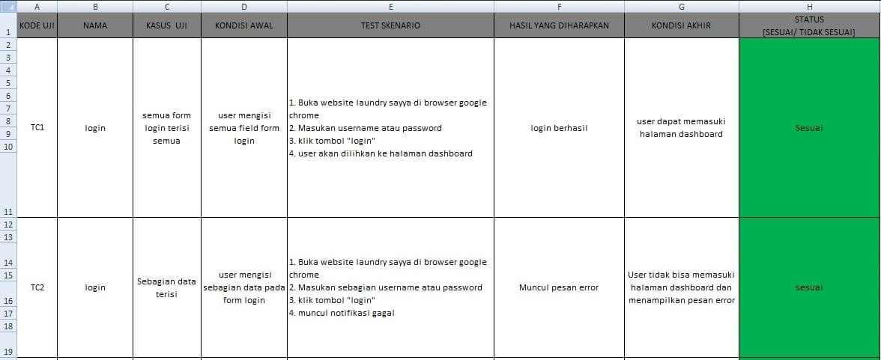

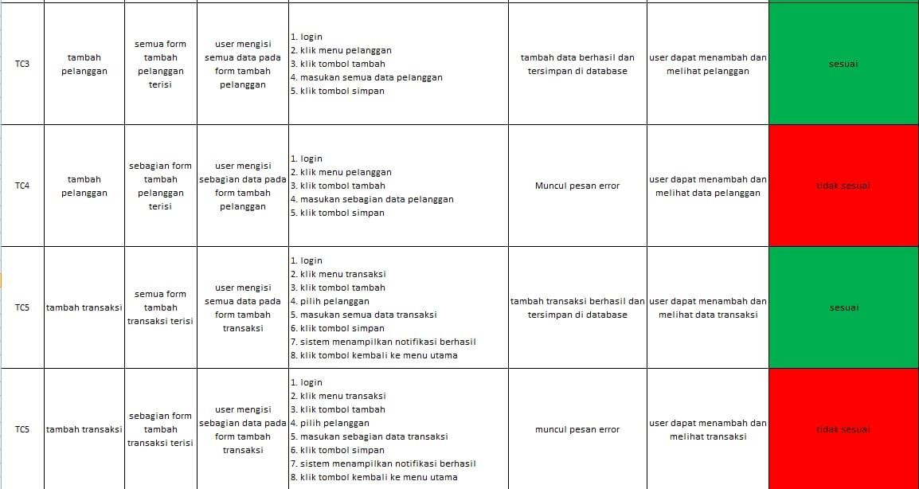

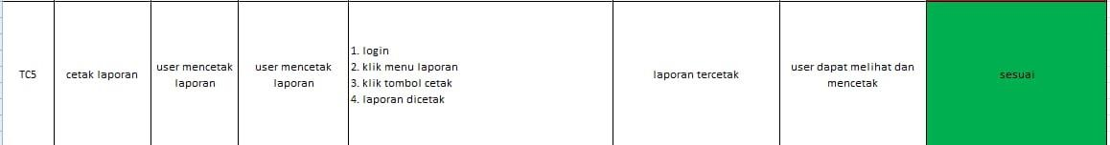

1. **Revisi**